Day 4

Tableau Visualization

End Result: <https://public.tableau.com/app/profile/justis.shaw/viz/PortfolioCovidDashboard_16923841474340/ProjectDashboard?publish=yes>

Isolated data set being used for visualization, then ran into a small problem.

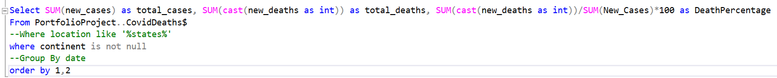

Hotkey needed to carry this over to Excel was being used by another program.

Changed hotkey, problem solved.

Creating 4 Excel documents to visualize using commands provided by Alex the Analyst with small changes to make it work with the way I worded my documentation.

<https://github.com/AlexTheAnalyst/PortfolioProjects/blob/main/Tableau%20Portfolio%20Project%20SQL%20Queries.sql>

Before some could be used for visualization in Tableau, NULL had to be replaced with an integer. In this case press ctrl + h to pull up Find and Replace and replace all NULLs with 0s.

Dates looking off as well so using Excel to fix those by selecting short date on the column. Fixed.

First Tableau Visualization: Global Numbers

Start by dragging data in order of appearance into the columns section, then in the Show Me tab, select text tables.

Increase size of the text for visibility, go to formay -> shading, change header to a calm and easy to read through color like pastel purple, and the pane to a light grey. Add black grid lines to separate data.

Then to specify death percentages further, currently it is 2, whereas we’d like it to be more specific like 2.11. Go to Measure Value, select the value we wish to change, select numbers, then Numbers (Custom) and adjust the decimal places by 2.

Output.

Second Tableau Visualization: Total Death Count Per Continent

Place location data into Columns, then SUM of Total Deaths into Rows, Tableau auto places this into a horizonal bars chart. Select location and sort manually to place in descending order. Rename Location to Continent. Dragging Continent table into the Marks and adjusting size, adding color to turn it a pleasant color scheme (gradient purple, using a lot of purple today apparently). Right click Total Death Count to begin editing the Axis to make the tick marks clearer, setting ticks to every 250k instead of 100k.

Output.

Third Tableau Visualization: Total Infection by Country

Change the Location Table into a geographic role Country/Region, which will generate a Longitude and Latitude tables, place those in the Columns and Rows sections respectively. Place Location and SUM Percentage Infected tables into the Marks tab which will outline the countries, and then color them in based on infection percentage. Change color in the SPI table to a red, cause red is the scary color.

Output.

Fourth Tableau Visualization: Total Death Count Per Continent

Dragging the Years to the columns, and Percentage of Population Infected to the rows section. By default it’s just two columns for the years, obviously this isn’t very helpful data so we’ll split that up into months of the year (different than just months, this one breaks it up into years as well, 2020/2021). Then we’ll break it up by location, adding color to it and creating a wonderful rainbow spaghetti. Then we will select location and filter to the areas we want to specify, in this case China, India, Mexico, United States and Kingdom. Add a forecast to the data to make an estimate of how numbers may grow, or falter based on previous data. Add labels to the numbers as they rise.

Output.

Assembling the Dashboard

This part is really jank, sliding things around until they end up in a spot that is satisfactory. In the future I can make more attempts to color coordinate and professionalize this. But for now, this is a great start.

Output.

<https://public.tableau.com/app/profile/justis.shaw/viz/PortfolioCovidDashboard_16923841474340/ProjectDashboard?publish=yes>

